**ADVANCED MAPPING TECHNIQUE IN NIGERIA, EDO STATE, SOUTH-WESTERN**

**NIGERIA**

**ADVANCED MAPPING TECHNIQUES**

**(GLY 413)**

**SUBMITTED BY:**

**OLADUNJOYE VICTOR O.**

**(GLY/2018/046)**

**TO DEPARTMENT OF GEOLOGY,**

**OBAFEMI AWOLOWO UNIVERSITY,**

**ILE IFE, OSUN STATE,**

**NIGERIA.**

**2023.**

**ACKNOWLEDGEMENT**

I would like to express my heartfelt gratitude to all those who contributed to the successful completion of this geologic mapping exercise. Their unwavering support, guidance, and expertise were invaluable throughout their endeavour.

**ABSTRACT**

The Igarra geologic mapping exercise lasted for a period of 14 days, 31st July to August 13th 2023. The main objective was study and map the three main rock types in the area, that is the Igneous, metamorphic and sedimentary rocks.

Methodologies used during the mapping exercise are the traverse methods used in the location of outcrops, such as road traversing, river traversing, compass bearing and global positioning system(GPS) was also used in locating and representing located outcrops on topographically grid maps to create a geologic map.

A geologic map was created at the end of the mapping exercise, showing boundary between the various dominant rock types in the regions of the area,such as the sedimentary, Igneous and the Metamorphic rocks.

The study area is geologically rich due to the relatively close proximity of the three different rock types to each other.

**TABLE OF CONTENT**

TITLE PAGE ------------------------ (i)

ACKNOWLEDGEMENT ------------------------(ii)

ABSTRACT ------------------------(iii)

CHAPTER ONE

* 1. INTRODUCTION -------------------------- 1
  2. LOCATION -------------------------- 1
  3. ACCESSIBILITY -------------------------- 3
  4. CLIMATE AND VEGETATION ----------------- 3
  5. METHODS OF MAPPING

1.5.1 LOCATING POSITION ON MAP

1.5.2 METHODS USED FOR OUTCROP AND GEOLOGIC BODY PROSPETING

1.5.3 EQUIPMENTS AND MATERIALS USED DURING THE EXERICSE

1.6 DURATION

1.7 PHYSIOGRAPHY/LANDFORM

1.7.1 PHYSIOGRAPHY

1.7.2 LANDFORMS

1.8 PREVIOUS WORK

1.9 AIMS AND OBJECTIVE

CHAPTER 2 GEOLOGY

2.1 SEDIMENTARY ROCKS

2.1.1 LOKOJA BASANJE FORMATION

2.1.2 MAMU SANDSTONE FORMATION

2.1.3 AJARLI SANDSTONE FORMATION

2.2 CRYSTALLINE ROCKS

2.2.1 METACONGOMERATE

2.2.2 PHYLLITE

2.2.3 QUARTZITE

2.2.4 SCHIST

2.2.5 CALC-SILICATE GNEISS

2.2.6 FAULT BRECCIA

2.2.7 METAMARL

2.3 IGNEOUS ROCK

2.3.1 GRANITE

2.3.2 SYENITE

2.3.3 LAMPROPHYRE

2.3.4 DOLERITE

2.3.5 PEGMATITE

CHAPTER 3 STRUCTURAL GEOLOGY

3.1 SEDIMENTARY STRUCTURES

3.1.1 BEDDNG PLANE

3.1.2 CROSS BEDDING

3.1.3 GRADED BEDDING

3.1.4 TRACE FOSSILS

3.2 MAGMATIC FLOW STRUCTURES

3.2.1 FOLIATION

3.2.2 SECONDARY STRUCTURES

CHAPTER 4 METAMORPHISM

4.1 METAMORPHISM AND DEFORMATION

4.1.1 REGIONAL METAMORPHISM

4.1.2 CONTACT METAMORPHISM

4.2 GRADE OF METAMORPHSM

4.3 EPISODE OF DEFORMATION

CHAPTER 5 GEOCHEMISTRY

CHAPTER 6 GEOLOGICAL HISTORY

CHAPTER 7 ECONOMIC GEOLOGY

REFERENCES

**LIST OF FIGURES**

FIG 1 Map of Nigeria showing Igarra.

FIG 2 Mamu Formation.

FIG 3 Ajarli Formation.

FIG 4 Metaconglomerate.

FIG 5 Strongly Folded Phylite.

FIG 6 Quartzite.

FIG 7 Calc-Silicate Gneiss.

FIG 8 Granite.

FIG 9 Lamprophyre

FIG 10 Pegmatite.

FIG 11 Mamu formation showing Bedding Planes.

FIG 12 Mamu formation showing Graded Beds

FIG 13 Deformation in Mamu Formation showing Fossil Impression.

FIG 14 Fold

**CHAPTER ONE**

* 1. **INTRODCUTION**

The Geology of Nigeria comprises crystalline basement rocks and sedimentary basins, almost in equal proportions. The ages of the basement rocks span Precambrian to early Paleozoic, having been consolidated during the Pan-African. The sedimentary basins are of Cretaceous to Recent age.

The study area Igarra and its neighbouring environments have been distinguished through various geological studies to be one of the few places in the country where the three different rock types, Igneous, metamorphic and sedimentary have been found to outcrop extensively and also intersect. Hence making it a the best training environments for professional geologists both in academic and industry wise.

The mapping exercise lasted for a period of 14 days, 31st July to August 13th 2023.

* 1. **LOCATION**

The geologic mapping exercise took place in Edo state, which is located in the South-South geopolitical zone of Nigeria. The studied areas include Igarra, Ojirami, Otua, Aiyetoro, Okpe, Somorika, Uzebba, Imiegba, Ifon.

The geographical coordinates of the study area lies on, latitude 6° 32' 37.716” and longitude 5° 53' 55.3704”.

Those distanced from the roads were accessed by footpaths. The map of the study area is shown below

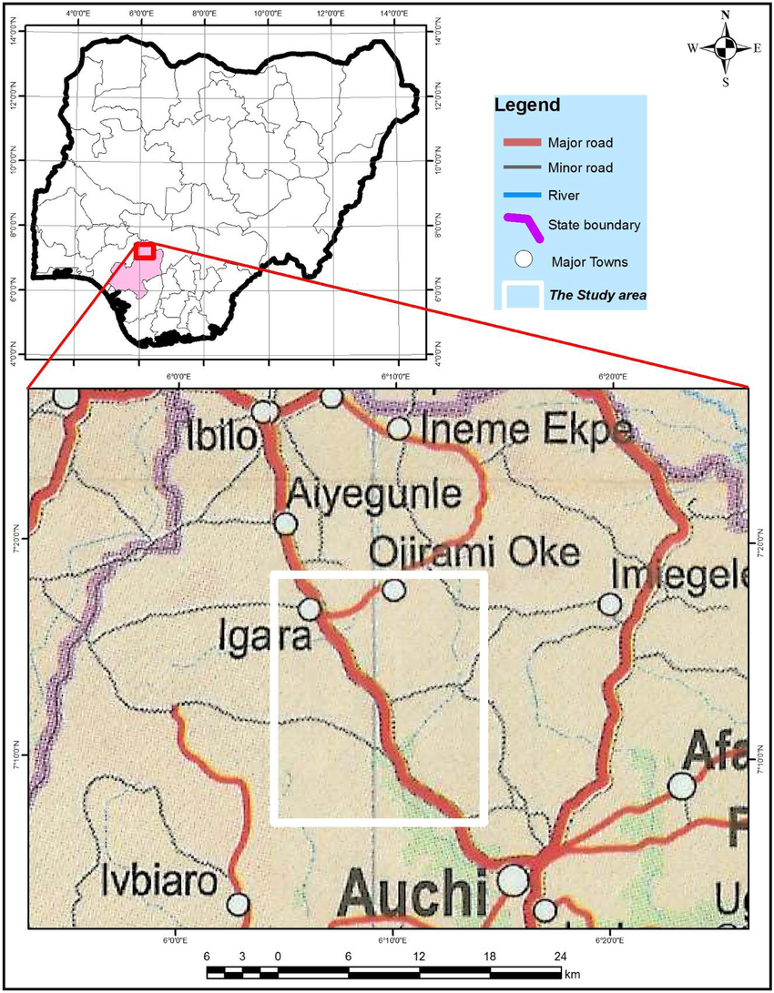

Fig1: Map of Nigeria showing Igarra, Edo state.

* 1. **ACCESSIBILITY**

The study area has a very good road network, major roads, minor roads and foot paths which made access to outcrops easier. Some roads are new and so are not represented on the map.

**1.4 CLIMATE AND VEGETATION**

The climatic condition of Igarra and its environments fall within the warm-horrid tropical climate region. The rainy season last for about seven months (May to October) and the dry season last for about five months (November to April).

Rainfall is moderate between the months of March and May and heaviest between June and September with Average rainfall between 1000mm and 1500mm and temperature as high as 36.7° especially within the hottest period of February to April.

The study area lies within the Guinea Savannah vegetation belt characterized by short trees and tall grasses. The vegetation here is prominently made of sparsely distributed trees, herbs, shrubs, and grasses.

The vegetation in this area is mostly secondary i.e. the natural vegetation is being altered and such agricultural crops.

The mapping exercise took place during 31st July to 13th August, which falls under the rainy season period of the study area.

Mist were observed to cover the top of the mountains and hills in the study area during the early hours of the day and noon if the sun is not at its peak. The rivers and streams were flooded and some exceeded the banks owing to the rainy season at the time.

**1.5 METHODS OF MAPPING**

The methodology includes the various techniques used in locate oneself on the topographical map and prospecting for outcrops during the geologic mapping exercise.

**1.5.1 LOCATING POSITION ON MAP**

Various techniques were used to locate ourselves on map during the geologic exercise, and they are listed below;

1. Locating by visual inspection of the map : This involves the use of features in the immediate environment be it cultural features like schools, houses and elevations like hills to get approximate location on the map.
2. Locating by Global Positioning System(G.P.S) : is a device used for getting the current position of the observer in three dimensions, degrees, minute and seconds for both longitude and latitude. It is not advisable for getting elevation readings due to the inbuilt system. There are errors in the lateral readings but are negligible for the exercise.
3. Locating by pacing and compass bearing: This is the most accurate of the methods, the pacing is converted to actual distance on ground by multiplying against the pacing rate in meters. The starting position is known, can be a major road or an identified feature on the map, then the compass clinometer is used to get the bearing of the position relative to a physical target ahead. Then the direction is plotted on the map relative to the geographical north of the map.

**1.5.2 METHODS USED FOR OUTCROP AND GEOLOGIC BODY PROSPETING**

Several methods were used for prospecting for outcrops and geologic bodies during the mapping exercise and they are listed as follows;

1. Road traverse : This is the easiest of the methods, it involves sampling of rocks and along the road and observing the gradation from a rock type to the other.
2. River Channel traverse: Most times when there are no outcrops or rocks bodies on the surface when there have been confirmed occurrences on the surface of the area in the past, it is best to investigate the river channels, they often have insitu evidences of the rock, most times weathered but still in compacted form.
3. Compass traverse: It is common knowledge among geologist that rocks are the same along the strike and different across the dip. To find a different rock type for marking of boundaries, it is best to investigate across the dip(dip is always less than 90° ).

**1.5.3 EQUIPMENTS AND MATERIALS USED DURING THE EXERICSE**

Several tools and machines were used during the mapping exercise to ensure the successful execution of the exercise. They are listed below starting from the must have for each participant to the machines.

1. A complete mathematical set for the diagrams and sketches made on the tracing paper and a long ruler at least 30cm.
2. A complete colour pencil set for representing geologic features and symbols on the geologic map.
3. A set of tracing papers to serve as overlay for the geologic map on the topographic map.
4. A geologic hammer for breaking rock samples.
5. A field boot for safety reasons against unexpected situation like boulders resting on the feet and for the harsh terrain.
6. A sample sack for carrying rock samples.
7. Two boards, a field board and base board for field maps and base respectively to avoid loss of progress in case of mishaps to the field map.
8. A compass clinometer for getting the compass reading of a location and obtaining strike and dip values for boundaries.
9. A permanent marker for making strike lines in the field and labeling of rock samples.
10. A raincoat for shelter in the field when the rain starts pouring.
11. Four pocket size field notes for documentation of field observations.
12. A hand lens for magnification of sample to get more details about the mineral composition, colour, and grain size.
13. Two topographic maps each for the intended locations to be visited for the base and field maps.

**1.6 DURATION**

The mapping exercise lasted for a period of 14 days, from 31st June to 13th August. The geology component lasted from 31st August to 10th of August.

**1.7 PHYSIOGRAPHY/ LANDFORM**

**1.7.1 PHYSIOGRAPHY**

The physiography features of the area such as landforms and drainage patterns in the study area, have resulted primarily from the interplay betwteen weathering (especially physial), erosion and geologic processes.

**1.7.2 LANDFORMS**

The study area has a rugged and high relief. The various landforms in the study area include the inselbergs, valleys and pediments which are described below:

**INSELBERGS**

An inselberg is an islolated hill or mountain, often heavily eroded on its lower slopes, rising abruptly from a plain which is characteristic of the late stage of erosion in a mountainous region. The inselbergs in the study area are commonly called the ‘Igarra Batholiths’.

They are mostly conspicuous features in the mapped region as they outcrop extensively in the north-eastern part of the region. They extend from Semolika in the north to Enwan in the south, stretching over 6.5km across and varying heights between 300m and 700m above the mean-sae level.

**PEDIMENTS**

Pediments are extensive gentle sloping plains of eroded bedrocks, developed form the highlands between streams belonging to the same drainage system. They slope at an angle of about 5° or less. They occur in the south western part of Igarra. The pediments are made of low-lying exposures, which are evidence of high susceptibility to weathering and denudation. The rock types therein are schist and calc-gneiss.

**THE REJUVENATING RIVER VALLEYS**

These river valleys exist between adjacent hills and are usually steep sided. These landforms are formed as a result of the streams and rivers dissecting the once extensive pediments. The pediments in the mapped area are made up of metaconglomerate and schist and they must have resulted either from the persistent and continuous weathering and erosion of the parent rocks or down warping and folding of the basement rocks due to tectonic activities.

**DRAINAGE PATTERN**

Simply put, drainage pattern is the arrangement of a river and its tributaries. The relief and topography of the study area influences the drainage pattern.

The drainage pattern of the study area centers around river Osse, which marks the boundary between Edo state and Ondo state. The trellis and dendritic drainage patterns were observed in the region. The tributary of river Onyami which flows in a north-east/south-west direction forms a trellis drainage pattern with the main river as it joins the main river at more or less 90 deg.

The dendritic pattern was observed very close to Sasaro (with the river flowing southwards) and Semolika (with the river flowing eastwarrds). Here the tributaries form acute angles with these rivers (such as comples branching of a tree.

However, the dendritic drainage pattern was observed mostly in the region.

**1.8 PREVIOUS WORK**

The study area was not recently discovered by us, and so there has been a lot seasoned and qualified geologists from within and outside the country that have worked extensively on the study area due to its uniqueness and geologic significance. Some of they are listed below:

Rahaman M.A. (1976) worked on the structural aspect of the igneous and metamorphic rocks in this region. In his paper titled “Review of the Basement Complex of South-Western Nigeria”, he classified the rocks in this region into six major groups based mainly on petrologic characteristics.

Ojok Ocan O. (2016) worked on the Igarra Schist Belt, Regional Metamorphism, Contact Metamorphism in his paper titled “The Structural and Metamorphic Evolution of the Igarra Schist Belt, Edo State, Nigeria”.

Odeyemi I.B published a paper titled “Lithostratigraphy and Structural Relationships of The Upper Precambrian Metasediments in Igarra AArea, Southwestern Nigeria”.

Dahunsi (1981) concluded that the metasdiments are of fluvial origin based on the sedimentological data obtained from the Ifon borehole.

Meju and Okeke (1985) had at various periods carried out geochemical investigation in this region, which has thus revealed a marble mineralization in the said region.

**1.9 AIMS AND OBJECTIVE**

The ultimate aim of this mapping exercise is to prepare a geologic map. A geologic map is the most fundamental of all compilations of geological data. It is of utmost importance for any geological investigation be it geochemical, hydrogeological, or geophysical exploration and exploitation of mineral resources.

The geologic map will contain the field observations like the different rock types and the geologic bodies like faults like faults and their respective boundaries, other observations like strike and dip values of foliation planes are also documented.

Measurements of axial plane cleavages and plunge/plunge directions of lineations are made and represented on the steronet.

The Sedimentary aspects aims to have a litho-log representation of the sedimentary deposits of the study area and also put the corresponding grain size and the method and rigour deposition from the noticeable structures on the deposits and also the grain size.

**CHAPTER 2**

**GEOLOGY**

**2.1 SEDIMENTARY ROCKS**

Sedimentary rocks are rocks formed as a result of sediments accumulation and compaction and also cemented together. During the mapping exercise, the following sedimentary rocks were observed:

**.** Sandstone

**.** Shale

**.** Siltstone

**.** Mudstone

**.** Ironstone

**SEDIMENTARY FORMATIONS**

A sedimentary formation is a mappable geologic unit that has a distinctive feature that differentiates it from other surrounding rock layers/ units.

The study area belongs to the western flank of the Anambra Basin, hence contains a good number of well exposed outcrops of siliciclastics that permit investigation into their origin and tectonic setting.

During the mapping exercise, sedimentary rocks were observed to have occurred as a formation. Some occurring as hilly exposures, others as road-cuts. The observed formations are 3 and they are listed below :

**.** Lokoja-Basanje Formation

**.** Mamu Formation

**.** Ajarli Formation

**2.1.1 LOKOJA BASANJE FORMATION**

The formation is found along the Igarra-Auchi road. It is occurring as a road-cut. It has an approximate height of 19m at its peak and length of 87m calculated to actual ground distance by pacing and pacing rate. The studied formation is popularly known as “Bawa Hill”. The colour is observed to change/grade from white/light to reddish brown at the top due to weathering. The pinkish colour observed on the outcrop were as a result of the mineral k-feldspar.

The formation is composed mainly of sandstone and it is a fining upward sequence that is coarse grained at the base and finer grains at the top.

Graded beds were observed on the formation cut section owing to the road cut, and the inference that they were deposited by deep marine environment was made which is a characteristic of graded beds. The mineral grains were angular thereby meaning a short traveled distance before deposition of the sediments.

There were no observable fossils. The mineralogy of the sandstone formation are Quartz and some feldspars.

**2.1.2 MAMU SANDSTONE FORMATION**

Mamu formation was studied as a roadcut in .The formation is a coarsening upward sequence. The sandstone is heterolytic, different grain sizes and has high carbon content consisting of carbonaceous shale, coal and clay. The formation is also called the lower coal measure. It is highly stratified with alternating lithologies and colour. The topmost part of the formation is lighter and whitish in colour but due to weathering there is a false weathered surface.

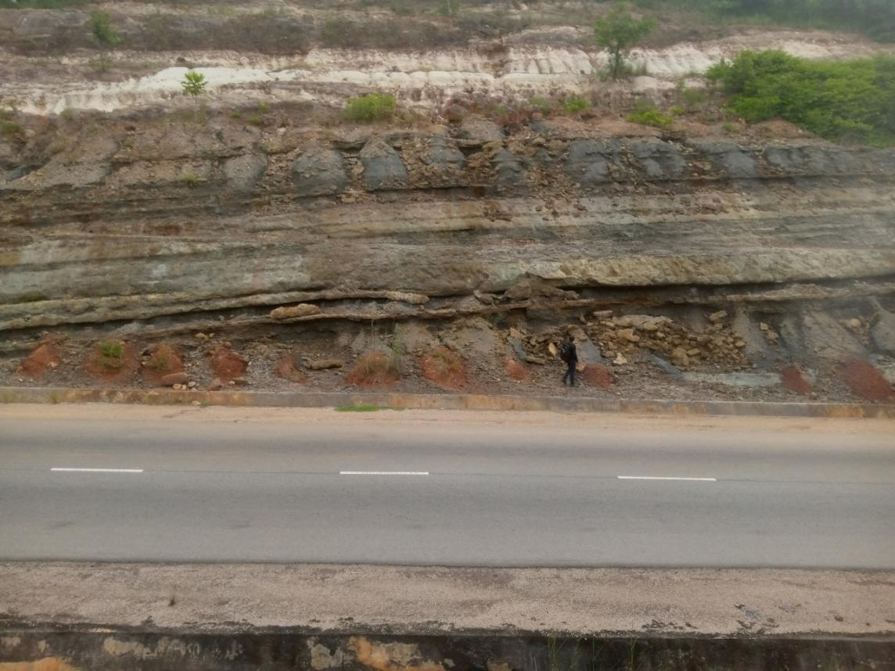

**Fig 2: Mamu Formation**

**2.1.3 AJARLI SANDSTONE FORMATION**

One of the places where ajarli sandstone outcropped as a formation is along Ifon-Uzebba road. The outcrop is hilly approximately 14m in height and very extensive. The locality is an active quarry for sandstone.

There is false reddish-brown colour due to weathering, on further inspection and sampling, the colour is white.

It is fine grained. The ajarli sandstone is texturally immature and it contains lots of clay and specs of feldspar. It is heterolytic due to its grain size orientation and arrange.

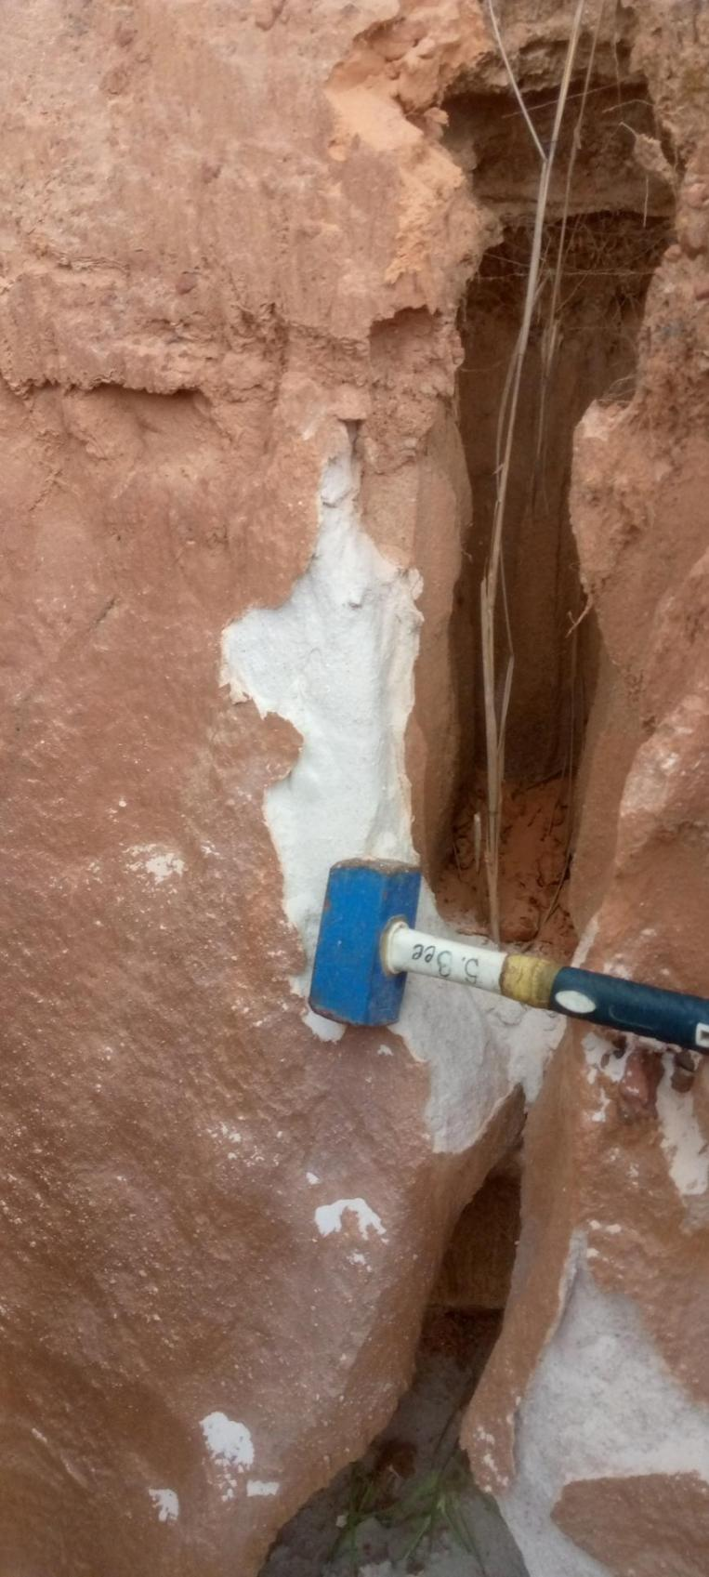

Fig 3: Ajarli Formation

**2.2 CRYSTALLINE ROCKS**

The rocks of the Igarra schist belt are mainly made up of Precambrian low-grade metasediments. They occur as a supercrustal lying uncomfortably on polycyclic basement of Liberian (2800 ± 200 million years) and Ebumean (2000 ± 200 million years), Odeyemi (1988). Odeyemi (1938) identified four groups of rock in Igarra area, they are:

1. Quartz - Biotite Schist
2. Mica Schist
3. Calc-Silicate Gneiss and marble
4. Metaconglomerate

**2.2.1 METACONGLOMERATE**

During the course of the mapping exercise, it was observed that the Igarra schist belt is dominated by the metaconglomerate. They were classified into two main categories, the clast supported and the matrix supported metaconglomerate. The matric is mainly composed of Pelitic rocks(schist, pellitic) while the clast are composed of quartzite, granite gneiss clast.

**2.2.1.1 Clast**

Due to different clast compositions we have the monomict which implies single clast composition and the polymict which is for multi clast composition. The clast supported have less matrix content relative to the overall rock composition. The pebbles touch one another and are often enlongated and ovoid in shape from few centimeters to a a hundred centimeters in length.

**2.2.1.2 Matrix**

The matrix has less pebble content and the matrix which is the binding and finer grains occupies a larger percentage of the rock volume relative to the clast. The clast are loosely arranged within the matrix and does not make up a significant amount of the rock’s volume.

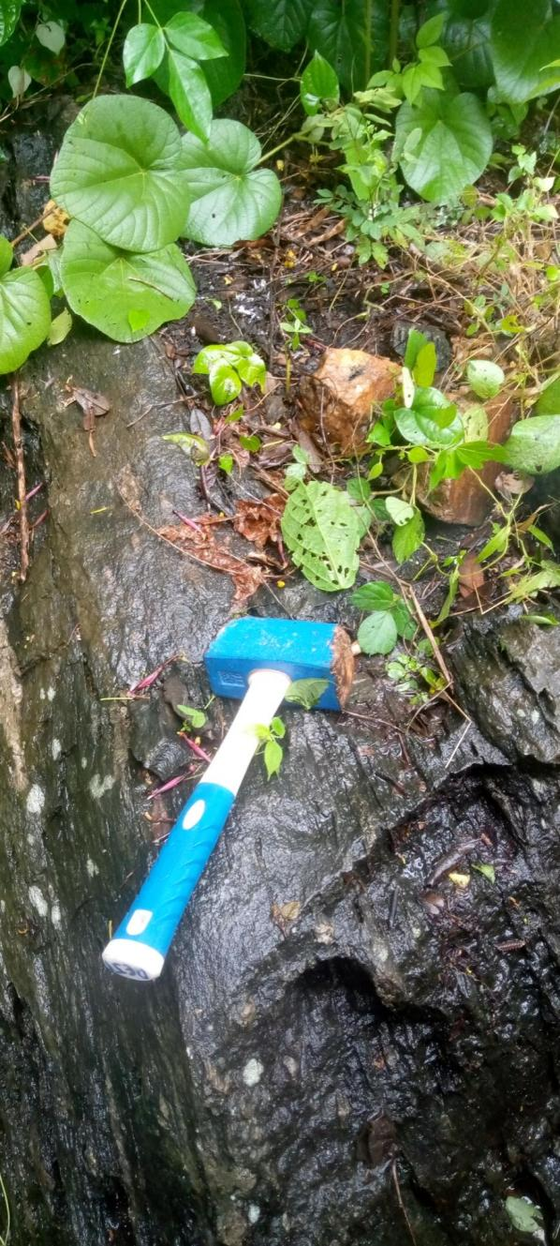

**Fig 4: Metaconglomerate**

**2.2.2 PHYLLITE**

Phyllite was observed at Igarra, Ojirami and other locations. The rock is predominantly grey with alternation of light and dark mineralogical banding. The studied rock has a fine to medium grain texture with some spotted hornfelsic texture and a silky sheen appearance due to its mica content. The phyllite is strongly foliated with alternation of psammitic and pelitic bands.

The dark bands are made up of minerals such as biotite, amphibole and pyroxenes while the light bands are composed of quartz, feldspar and muscovite.

The spotted holes on the rock surface are due to the prior presence of biotite, amphibole and pyroxenes which have now been weathered due to the high susceptibility of the minerals to weathering.

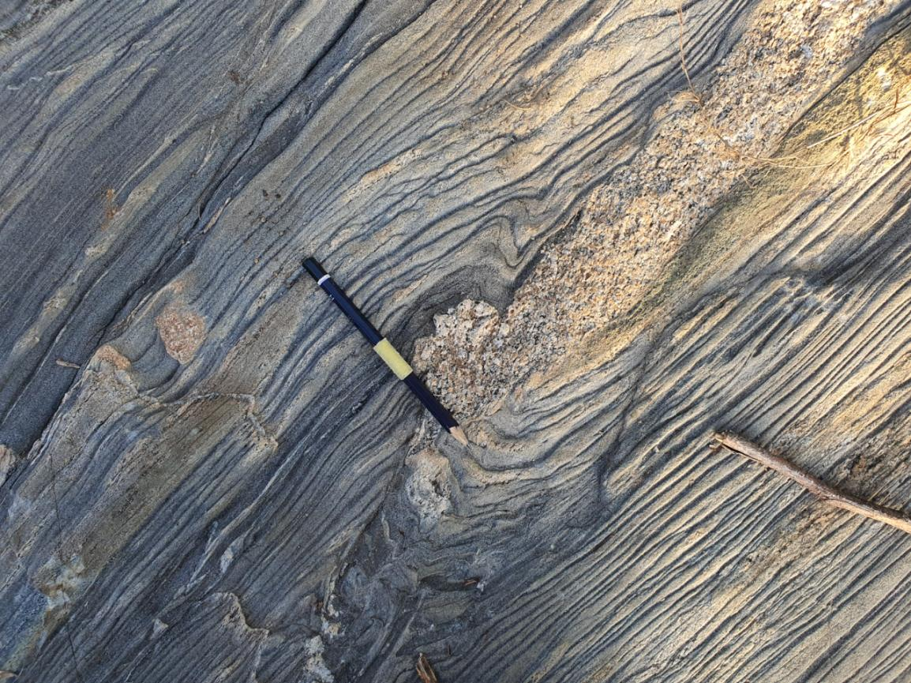

**Fig 5: Strongly folded Phylite**

**2.2.3 QUARTZITE**

Quartzite is widely distributed in the Igarra area. Samples found were strongly weathered and were also in rubbles. It occurs as an enclave at the basement of the Semolika granite and fragments in Igarra area.

The studied rock has a whitish yellow colour due to the effects of weathering. Texture is granular, grain size is medium grained.

Contact was established in the field between quartzite and metaconglomerate and another between quartzite and phyllitic schist, with both lying side by side. Hence, it can be deduced that quartzite and phyllite were deposited at the same time. Quartz veins were observed cutting across the quartzite discordantly, indicating that it was later and younger.

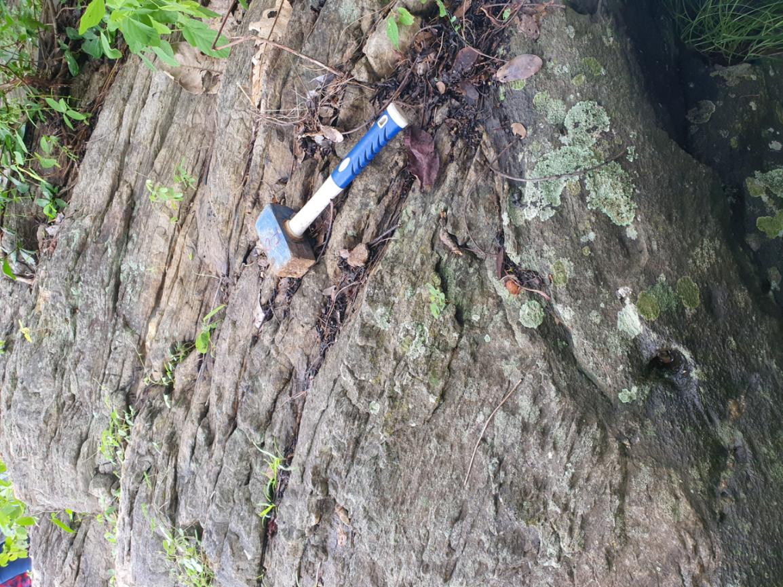

**Fig 6: Quartzite**

**2.2.4 SCHIST**

Schist is metamorphic rock in which lamellar minerals, such as muscovite, biotite, and chlorite, or prismatic minerals such as hornblende and tremolite, are oriented parallel to a secondary platy or laminated structure termed schistosity.

**2.2.5 CALC-SILICATE GNEISS**

Calc-silicate gneiss was studied and identified at Ikao and Igwe. It was observed to contain mineralogical and lithological banding. The mineralogical banding is characterized by alternation of quartz and biotite rich minerals while the lithologic band is characterized by alternation of stained white rock rich in calcium with grey metapellite giving rise to gneissic banding.

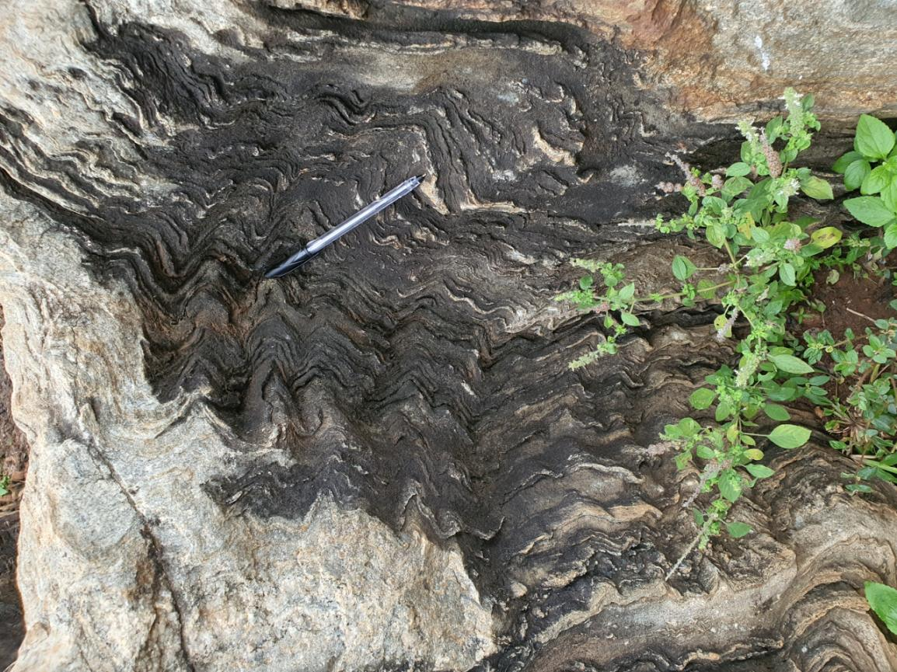

**Fig 8: Calc-Silicate Gneiss**

**2.2.6 FAULT BRECCIA**

Fault breccia was found in the Igarra area. The clasts are randomly oriented, it is clast supported. The clasts are very coarse, angular and disoriented.

They are believed to have been formed by very energetic magma or a fault giving rise to the name. The white clasts are metamorphic rocks whith sizes ranging from small to large and they are scattered within the matrix.

The composition of the clasts varies with some similar to those embedded in metaconglomerates, while some are similar to matrix. The matrix has a dark grey colour and the clast white.

The mineralogy consists of biotite, quartz, feldspar and chlorite.

**2.2.7 METAMARL**

Metamarl was found in Igarra during the study area, it was inaccessible due to the flooded river covering almost all parts of it.

**2.3 IGNEOUS ROCK**

**.** Granite

**.** Syenite

**.** Lamprophyre

**.** Dolerite and Felsic Dyke

**.** Pegmatite

**2.3.1 GRANITE**

Two forms of granite were observed in the field, namely;

**.** Porphyritic Granite.

**.** Coarse-grained Granite.

Both occurred as hilly exposures in the study area.

**Porphyritic Granite:** The rock has a pinkish colour due to the high k-feldspar content. These k-feldspar occur as large phenocrysts in a finer matrix, hence giving the rock a porphyritic texture. These phenocrysts are of various sizes ranging from 0.5cm-5cm in length, and they are often rectangular.

The mineralogical content includes quartz, k-feldspar, biotite, muscovite, and other mafic minerals.

**Coarse-grained Granite:** The rock was identified in … . The rock has a light grey colour with a coarse grained texture. The rock is light grey as they were emplaced at a higher crustal level compared to to the porphyritic granite.

The mineralogy includes quartz, plagioclase feldspar, biotite, muscovite and k-feldspar.

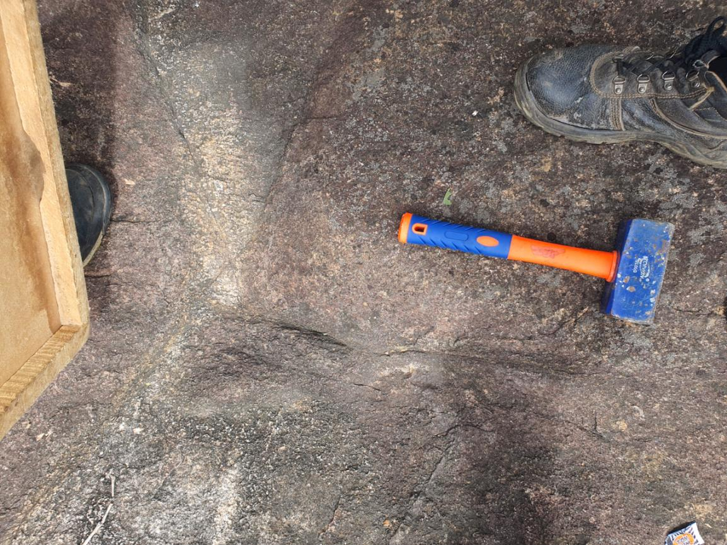

**Fig 9: Granite**

**2.3.2 SYENITE**

Syenite occurs as an obliqu intrusive igneous dyke in the study area. It occurs both as a low-lying exposure and also as a hill. It is typically dark grey with some green patches and the grains are fine to medium size.

There are two textural varieties of syenite, the fine and the coarse. The finer variety intruded first before the coarse: hence the finer is older than the coarse.

Xenoliths of dark grey syenite were observed in the lighter variety which further confirms that darker syenite is older.

The mineralogy includes quartz, biotite and mafic minerals.

**2.3.3 LAMPROPHYRE**

Lamprophile basically occurs as an intrusion cutting across the country rocks. It is dark grey in colour with fine to medium grain size. It contains phenocrysts of mafic minerals such as biotite embedded within a finer-grained matrix

The mineralogy includes quartz, k-feldspar, amphibole, pyroxene and olivine.

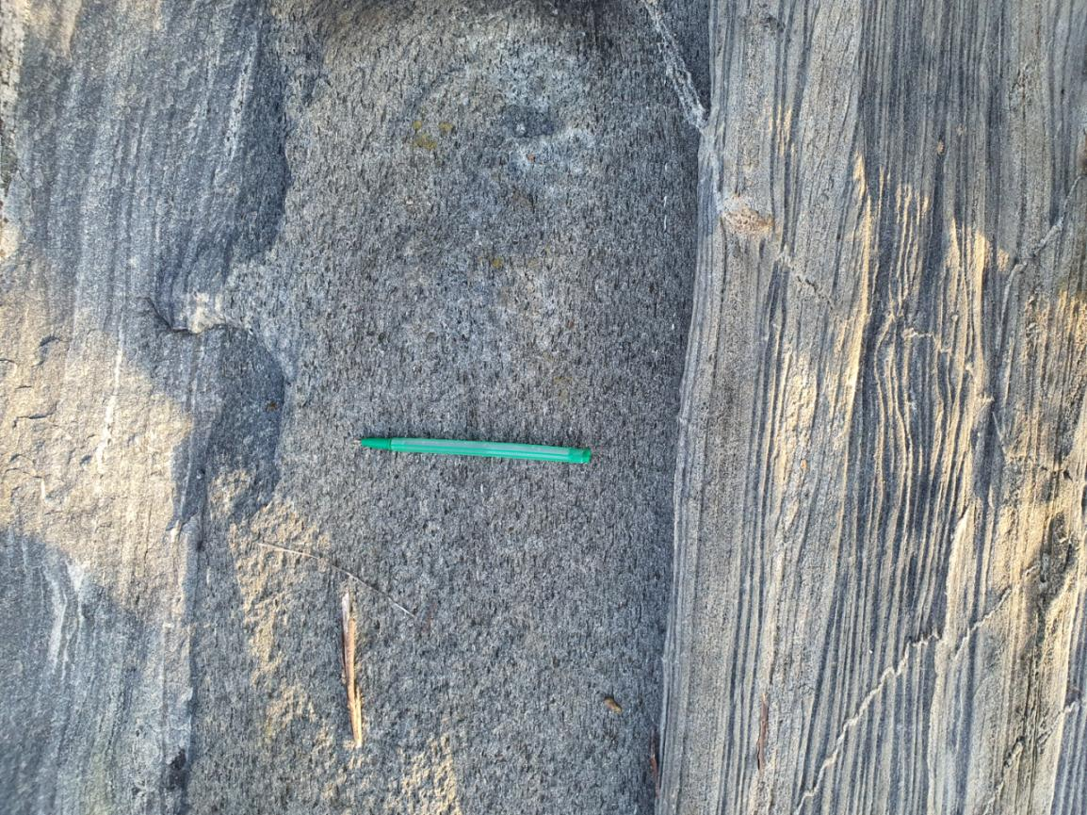

**Fig 10: Lamprophyre**

**2.3.4 DOLERITE**

Dolerite occurs as a dyke in the study area. It is dark grey because of its high mafic mineral content and has a fine-grained texture.

The cross cutting relationship indicates that dolerite is the youngest rock in the study area.

The mineralogy includes calc plagioclase, pyroxene, olivine, and amphibole.

**2.3.5 PEGMATITE**

Pegmatite occurs as a dyke in the metaconglomerates within Igarra area. It has both white and pinkish colouration. The pinkish colouration is due to high k-feldspar content in the host rock. It is very coarse grained due to its quartzo-feldspathic composition.

The thickness varies from 0.3cm to about 15cm and it developed a margin along the contact of the host rock.

Quartzo-feldsparthic pegmatite was observed to occur as a dyke. This indicates that it is younger than the schistose psammite.

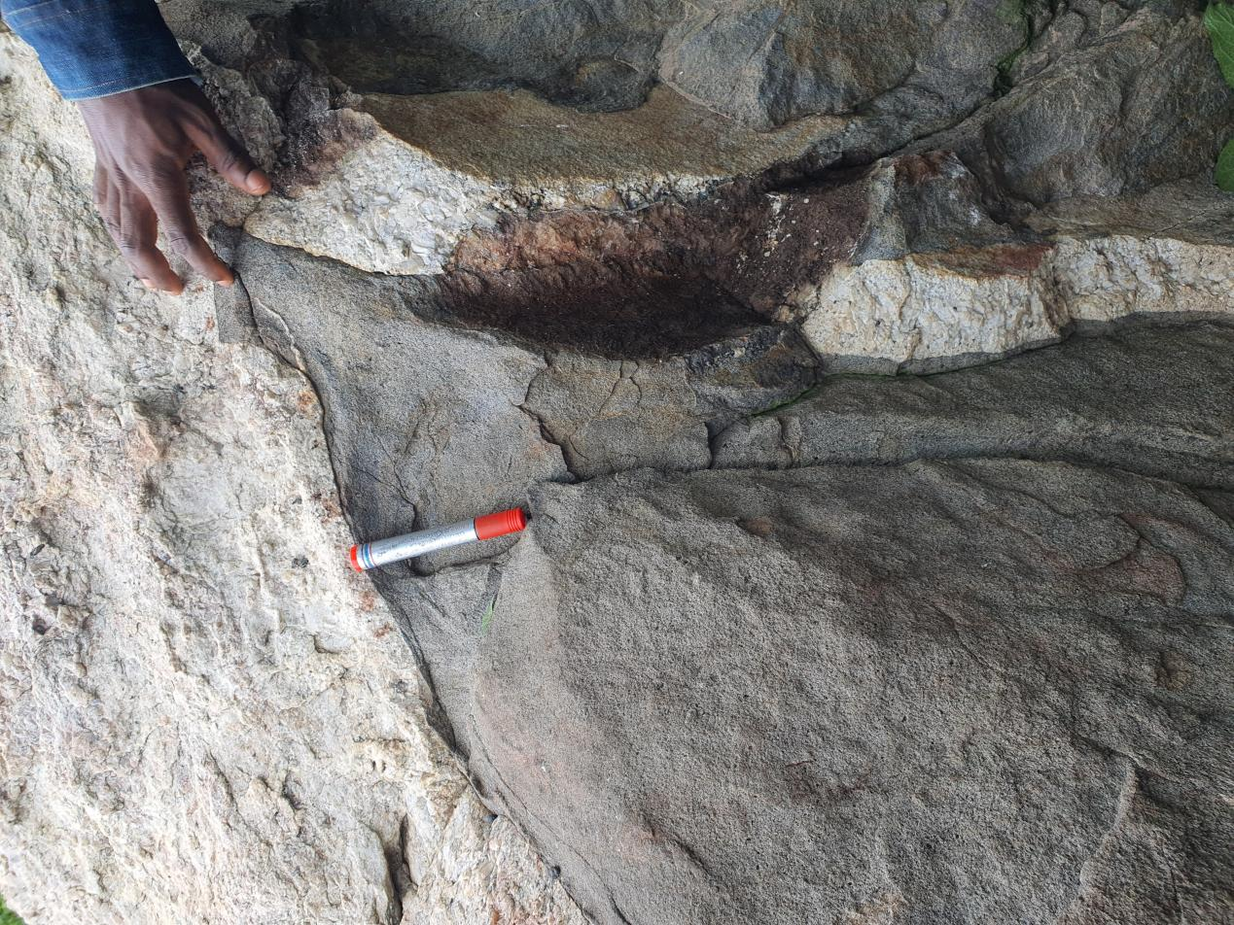

**Fig 11: Pegmatite**

**CHAPTER 3**

**STRUCTURAL GEOLOGY**

During the course of the mapping exercise, geologic structures were observed both in crystalline and sedimentary rocks. This chapter is divided into two, namely;

1. Primary Structures
2. Secondary Structures

**PRIMARY STRUCTURES**

Primary structures observed in the field are grouped into two, namely;

1. Sedimentary structures
2. Magmatic flow structures

**3.1 SEDIMENTARY STRUCTURES**

Sedimentary structures were observed during the mapping of the sedimentary rocks in the study area. They are non deformational structures and are basically associated with sedimentary processes that give rise to the sedimentary rocks. The following sedimentary structures were observed during the mapping exercise:

**.** Bedding Plane

**.** Cross Bedding

**.** Graded Bedding

**.** Trace Fossils

**3.1.1 BEDDING PLANE**

Bedding planes are horizontal geologic structures found in sedimentary rocks, each plane indicates a change in sediment depositional conditions.

Bedding planes were identified in Mamu formation and also Lokoja-Basanje formation, They were very obvious in both formations. The beds were approximately horizontal.

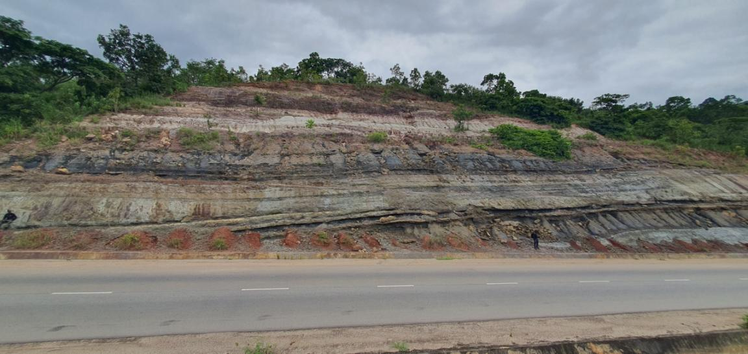

**Fig 12: Mamu formation showing Bedding planes**

**3.1.2 CROSS BEDDING**

Cross bedding also known as cross stratification, is layering within a stratum and at an angle to the main bedding plane. They record the flow direction of the current that deposited them.

Herringbone pattern which is a feature of cross bedding was identified at the Lokoja-Bassanje formation and also in Ajarli sandsstone formation.

**3.1.3 GRADED BEDDING**

Graded bedding is a bed cahracterized by a systematic change in grain or clast size from fine to coarser within a bed.

Graded beds are formed when a variety of sediments are dumped into a relatively still body of water, the particles then settles at different rates depending on the relative grain sizes and shapes.

Graded beds were identified at Bawa hill, conclusion is as a result of the fining upward sequence observed in the beds, that is coarser at the base and finer at the top.

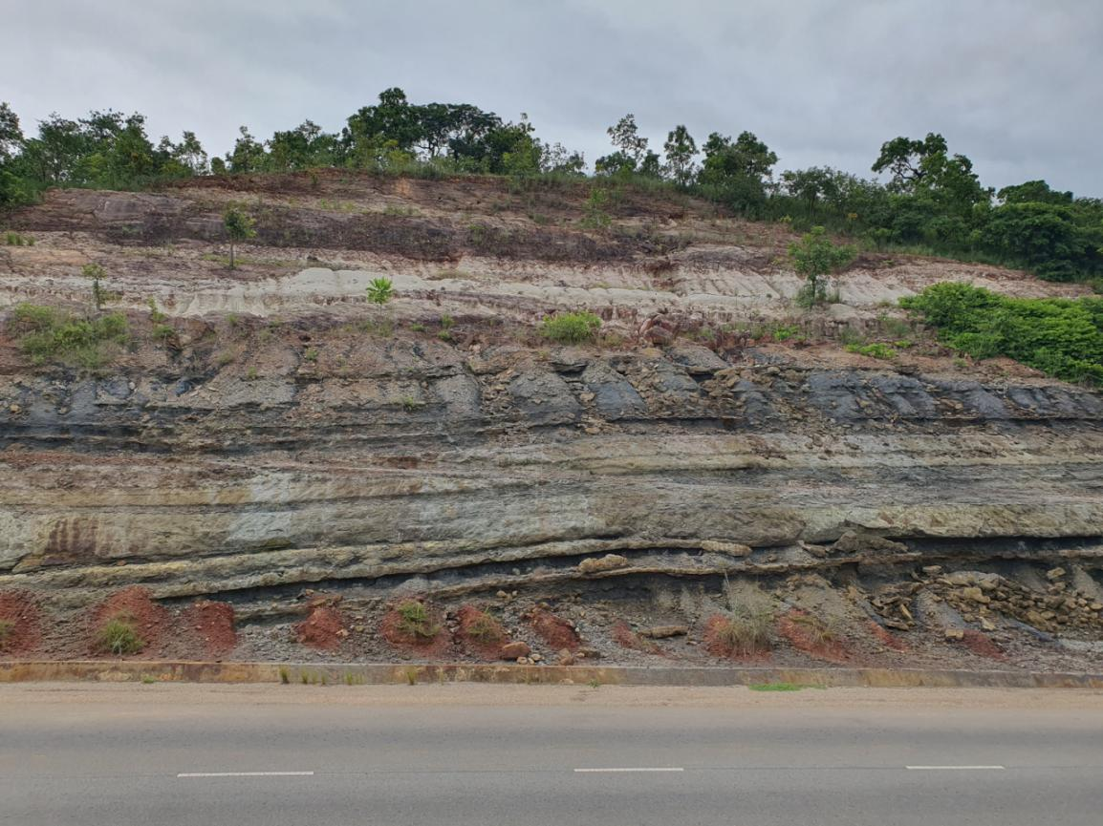

**Fig 13: Mamu Formation showing graded bed**

**3.1.4 TRACE FOSSILS**

Trace fossils are preserved impressions of living organisms in sedimentary rocks.

Impressions such as bioturbation and burrows of animals that destroyed a stratigraphic layer was seen in the Mamu formation. Burrows were also seen in the Ajarli formation at Fugar.

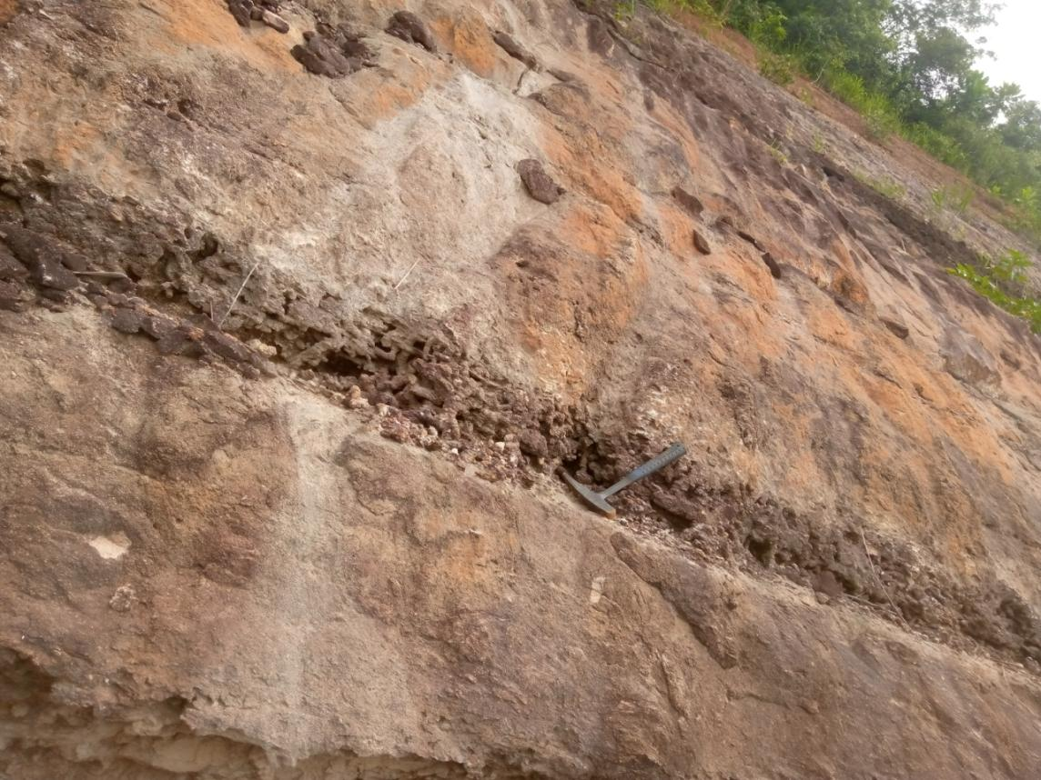

**Fig 16: Deformation in Mamu formation showing fossil impression. Bioturbation.**

**3.2 MAGMATIC FLOW STRUCTURES**

Magmatic flow structure is a flow fabric formed as a result of magmatic processes occurring within the Earth’s crust. It involves the movement of magma through pre-existing fractures in the brittle lithosphere and its subsequent cooling and crystallization into different minerals.

There are two types of magmatic flow structures, namely;

**.** Platy flow structures

**.** Linear flow structure

During the mapping exercise, the two types of magmatic flow structures were observed. Primary fabric is a type of platy flow structure that is due to the parallelism of platy minerals. The micro-granite at Ojirami-Oke exhibits a flow fabric with the preferred alignment of platy minerals. This flow fabric was completely discordant to that of the country rock.

**3.2.1 FOLIATION**

Foliation refers to the repetitive layering or alignment of mineral grains or structural features within a rock.

The foliation observed on the major hard rocks of the study area is secondary and often referred to as rock cleavage and its based on mineralogical and lithological banding.

**Mineralogical Banding:** This is the parallel alignment of alternating bands of light and dark coloured minerals. They result from the recrystallization in a rock during the first episode of metamorphism. This type of banding wad identified in the metaconglomerate at Ojirami parallel to the lithologic banding.

**Lithological Banding:** This is a relict sedimentary structure characterized by the alternation of different rock bands give rise to S **̥** surface. This type of banding was observed in the metaconglomerate, calc-gneiss and pelitic rock studied at Ojirami, Otuo and Ikao.

**Axial Plane Cleavage:** This results from the second episode of deformation which resulted in the deformation which resulted in the formation of F₁ folds. The axial plane cleavage forms the S₂ surface. The axial plane cleavage at Ojirami was seen reflecting from one band to another. This refraction is due to rheological differences or competency contrast between the bands.

**3.2.2 SECONDARY STRUCTURES**

These are deformations and features in rocks that occur as a result of stress, strain, or tectonic forces acting on pre-existing rocks. They are also called tectonic structures and can be grouped into:

**.** Mega structures

**.** Meso structures

**.** Micro structures

**3.2.2.1 MEGA STRUCTURES**

Mega structures are structures of brittle deformation. When a rock is subjected to pressure and its elastic limit exceeded, it undergoes brittle failure deformation. These structures occur on a regional scale and they include major faults, and large fractures.

**3.2.2.1.1 MAJOR FAULT**

This is a type of fracture in a rock along which there has been relative movement displacing the wall rocks on either side of the fault. Both the normal and reverse faults were identified at Ojirami. The normal fault results when the down thrown side is in the direction of the dip or when the hanging wall moves upward relative to the footwall. There is a major dip-slip fault observed between fault breccia and quartzite in the North Western par of Igarra. The fault has a bearing of 240°. The fault plane is exposed at N 7° 17’ 53.6”, N 6° 5’ 53.3”.

**3.2.2.1.2 LARGE FRACTURE**

Joints are brittle-fracture surfaces in rocks along which little or no displacement has occurred. Joints were observed in the Igarra batholith, and they were serving as pathway for streams and root for plants.

**3.2.2.3 MESO STRUCTURES**

Meso structures are secondary structures that occur on an outcrop scale in rocks and are produced by deformation combined with metamorphism and fluid activity. Such structures include folds, shear zones and faults.

**3.2.2.3.1 STRUCTURES OF BRITTLE DEFORMATION**

Brittle deformation gives rise to structures such as faults, joints, and tension gashes.

Fault is a fracture in rock along which there has been little or no displacement. Fault breccias observed during the mapping exercise indicate fault planes.

Joints are fractures along which there has been little or no displacemnt. Joints are ubiquitous, in that, they are present in almost if not all of the hard rock outcrops visited. These joints hosted plants and shrubs.

**3.2.2.3.2 STRUCTURES OF DUCTILE DEFORMATION**

These are structures produced from the plastic or ductile response of rocks to deformation. They include:

**Small Scale Folds:** These are microfolds observed on outcrops. They are associated with less competent rocks.

The F1 Folds resulted from the second episode of metamorphism (M2) and deformation (D2). This led to the folding of the lithological bands (S0) and mineralogical bands (S1) and the formation of the axial plane cleavage which represents the S2 surface.

The F2 Fold resulted from the third episode of deformation which is a contact metamorphism. They occur as steeply dipping, tight to isoclinal folds with small wavelength and large amplitudes in Ikao and open folded in Ojirami. This third episode of deformation caused the initial folds F1 to be refolded to produce F2 folds. However, this refolding could not produce S3 surfaces.

These small scale folds include; drag folds, vertical upright folds, chevron folds, overfold, antiform open fold and sigmoidal shaped folds caused by crenulation.

**Drag folds** are produced as a result of shearing when competent beds slide past an incompetent bed. Drag folds are observed along Ojirami Oke road; they are found to be sinistral that is in a clockwise sense of direction.

**Symmetrical fold** has itsaxial plane is essentially vertical. The axial plane of this fold is about vertical, plunging north-west.

Chevron kink fold is a fold in which the hinges are sharp and angular. The attitude of the axial plane of the fold is 1800 and 220 N`E. The chevron kink fold is formed with folded lineation.

Overfold-In this kind of fold, both limbs dip in the same direction usually at different angles. The axial plane is also inclined. The overturned or reversed limb is the limb that has been rotated through more than right angle to attain its present attitude.

Shear folding results from minute displacements along closely spaced fractures (secondary S-surfaces) not parallel to the original bedding (S0). It is also known as slip folding. Brittle shear zone, ductile shear zone, brittle-ductile shear zone are the types of shear zones. An east-west ductile-brittle shear zone shear zone with width of about 65cm was observed on the quartzite exposure. Within the shear zone, all the pre-existing structures were destroyed due to cataclastic deformation.

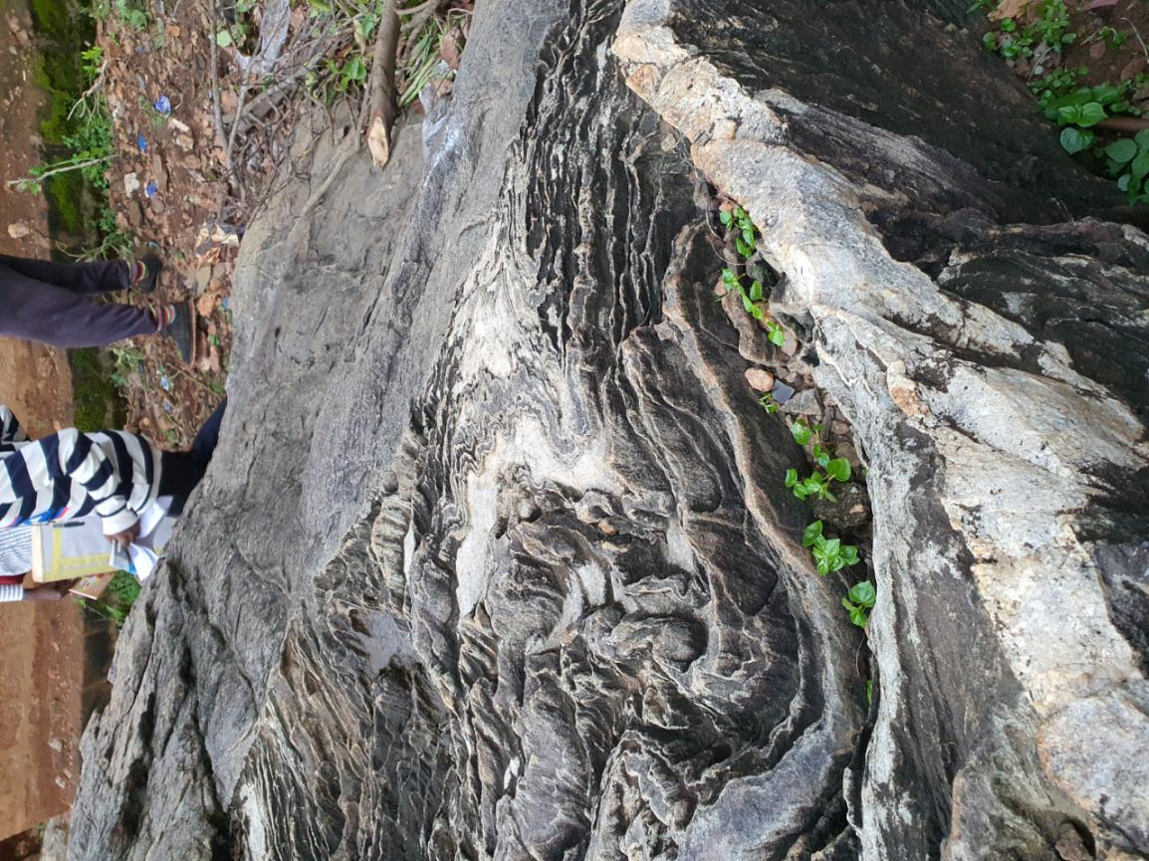

**Fig 14: Fold**

**LINEAR STRUCTURES**

These are structures formed by the elongation of minerals in a preferred direction. The preferred alignment of pebbles in metaconglomerate, the platy arrangement of micas (biotite and muscovite) in schist and phylllite and the alignment of phenocrysts of k-feldspar in granite gives a linear structure/lineation.

At Ojirami, the intersection of S0 toS1 plane on S2 foliation plane produced the linear fabric L1 of direction 1770 and plunge 430. The S2 plane produced the linear fabric L2 on S1; L2 has direction 1700 and plunge 400.Some of the linear structures observed are slickenside, boudins, and mullion structures.

Slickenside is a type of lineation associated with fault planes; it may be due to concentric shearing on bedding planes or to small scale offsetting on shear joints. That is, they are surfaces with striations and fine texture along which tectonic movement had occurred. In some cases, the scratches may be very obvious and clearly indicate the direction of movement. At other cases, a streaking caused by concentration of dark minerals along certain lines may be caused by sliding of layers past one another.

Slickenside is identified in the field by the movement of ones palm over the suspected surface; along a certain direction the surface is smooth, while in the reverse direction it is rough. This structure was noticed on the syenite intrusion along Igarra-Auchi road .

Boudinsare ‘pinch and swell’ structures which are formed as a result of the difference in the competence of the psammitic and pellitic bands with the psammitic bands being more competent. They are formed when relatively strong layers of rock are stretched and become elongated during deformation. They may separate into blocks or pillow-shaped structures separated by narrow necks. The process of elongation that produced boudins is called boudinage. Where the separation is incomplete and the layers show a narrowing or “necking”, the structures are often termed pinch-and-swell structures.

Boudins are particularly useful as indicators of the directions of extension in very intensively deformed rocks.

Mullionsare rod-like structures resulting from both brittle and ductile deformation. That is, they are series of parallel columns formed at the interface between competent and incompetent layers. It results partly from the folding of the interface and partly from the effect of bedding-foliation intersection. Mullions are nearly horizontal lineations.

Mullions were observed on the quartzite exposure; it measures about 0.19m wide and about 2.5m long.

**CHAPTER 4**

**METAMORPHISM**

Metamorphism refers to the process by which rocks undergo changes in mineral composition, texture, and structure due to alterations in temperature, pressure, and the chemical environment without melting.

This geological process typically occurs deep within the arth’scrust where temperatures and pressures are significantly higher than the Earth’s surface.

The rocks of the Igarra schit belt have undergone several series of metamorphic deformation series. Within the study area, it is believed that the metasediments were originally sedimentary rocks that underwent subsequent metamorphic transformation. In certain locations, the effects of metamorphism and deformation have entirely eased the original sedimentary structures, while in other areas, these structures have been preserved.

Odeyemi (1988) suggested that the metamorphism in the study area did not exceed the green schist facies. The metamorphism in the study area has been explained or described using field observations.

**4.1 METAMORPHISM AND DEFORMATION**

The study area falls into the basement complex region. Over the years, extensive works have been done on the basement complex, and attempts have been made to classify the different rocks found in the study area.

Deductions from texture, mineralogy and other observable feature in the area shows that there are two types of metamorphism that has taken place in the area which are:

**.** Regional Metamorphism

**.** Contact Metamorphism

**4.1.1 REGIONAL METAMORPHISM**

Regional metamorphism is an extensive type of metamorphism that affects large portions of lithospheric plates in which pressure and temperature are the determinant factors.

The metamorphic rocks found in the Igarra North-West region are located within the Basement Complex. These rocks predominantly consist of metasediments, gneisses, and migmatites, and they have formed as a result of several episodes of regional metamorphism, which altered the ancient sedimentary layers that once covered the study area.

Based on field observations and the gathered data, it can be inferred that the Igarra area has undergone a minimum of two episodes of regional metamorphism (M) in association with tectonic deformation (D). The first metamorphic event (M₁) linked to the initial deformation (D₁) caused the alteration of the pre-existing sedimentary bedding into lithological layering (S̥), as well as the recrystallization and alignment of biotite grains, forming mineralogical banding (S₁). The second metamorphic episode (M₂), coinciding with D₂ deformation, had an impact on the fabric formed during M1₁, leading to the development of axial plane cleavage (S₂) and the initiation of the first folding activity (F₁). This subsequent metamorphism and deformation (M₂ and D₂) altered the original fabric resulting from the initial deformation episode.

**4.1.2 CONATCT METAMORPHISM**

Contact metamorphism occurs as a result of rocks being subjected to high temperatures and moderate to low pressures due to proximity to heat source, typically an intrusion of molten magma.

Due to the intense heat, the rocks in contact with the heat source typically magma are called is called Aureoles. Metamorphism alters their mineralogical and textural attributes.

The third phase of metamorphism (M₃) can be described as a contact metamorphic event that occurred concurrently with deformation (D₃). This event took place within the region that had previously experienced regional metamorphism, leading to the restructuring (F₂) of the original folds. This subsequent event resulted in the re-folding of the existing foliation (S₂) on a smaller scale, leading to the formation of shear fractures referred to as "strain-slip" cleavage or "crenulation" cleavage (S₃). S₃ is oriented obliquely to S₂, while S₂ is inclined concerning S̥-S₁. The manifestation of this overlaid metamorphism is particularly evident at location 39, where distinct, large andalusite crystals were consciously found within the metapellites.

**4.2 GRADE OF METAMORPHISM**

Grade of metamorphism implies the degree of metamorphic alteration and the intensity of the physical and chemical changes that a rock has undergone. Different grades of metamorphism result in the formation of distinct mineral assemblages and texture within the rock.

In areas affected by contact metamorphism, the level of metamorphism varies depending on the distance from the igneous intrusion. Rocks closest to the intrusion experience high-grade metamorphism, characterized by minerals formed under high-temperature conditions. As you move further away from the intrusion, the rocks exhibit lower-grade metamorphism, with minerals indicating lower temperatures. For instance, the presence of andalusite in mica schist at locality 39 suggests a lower grade of metamorphism, indicating a greater distance from the granite intrusion.

On the other hand, the discovery of garnet and staurolite within mica schist at locality 40 signifies a medium-grade metamorphism, indicating its proximity to the igneous intrusion. This progression demonstrates a transition from low-grade to medium-grade metamorphism and aligns with the characteristics of the green schist and amphibolite facies in the metamorphic sequence.

**4.3 EPISODE OF DEFORMATION**

Episode of deformation in metamorphism refers to a specific period or event during which the rocks experience tectonic stresses that result in changes to their structure and orientation.

S̥ stress axis coincide with S₁ axis. S₁ underwent deformation and was folded to form axial plane foliation to form S₂. The last deformation stage is fracture.

**CHAPTER 5**

**GEOCHEMISTRY**

Geochemistry is a branch of Earth science that focuses on the study of the chemical composition, distribution, and behaviour of elements and compounds in the Earth’s crust, oceans, atmosphere, and other components of the planet.

The geochemistry aspect of the mapping exercise took place in Igarra area. The study area is a stream channel and soil samples were taken using large bowls and sieve nets. Gloves were used to reduce contamination of the sampled soils, ornaments like jewelries were also taken off by the geochemist taking the sample.

The sampling exercise took place in the secondary environment. G.P.S coordinates N70 16’ 29.1”, E 0060 7’ 45.3”.

The soil samples were taken upstream in the center of the stream in order to reduce sampling disturbed soil samples. Holes were dug in the stream sediment so the bed sediments can be taken, and left for a few minutes so the flowing river can clear the muddy water, then the large bowl is used to scoop the soil, then the scooped in soil is washed with the stream water, then sieved with a 230 micron sieve net to filter of coarse grain sizes and the very fine sediments are left in the sieved.

After the sampling of the stream sediments, samples were taking on the solid earth close to the stream, laterite was the target, hand augers, hammers were used to drill to the laterite, and samples were taking using transparent sampling sacks.

The main objective of the analysis is to know the anomalous concentration of elements in the area.

**CHAPTER 6**

**GEOLOGICAL HISTORY**

To grasp the geological framework of Igarra, one must delve into the area's ancient past. Approximately 600 million years ago, during the Proterozoic Era, Igarra occupied a position on the outer edge of a continental plate known as the West African Craton. This craton consists of ancient rocks that have endured significant tectonic activity spanning countless millennia. This prolonged geological activity led to the creation of various rock units and the emergence of mineral deposits that now characterize Igarra.

The geological terrain of Igarra encompasses a diverse array of rock formations that provide valuable insights into its geological history. The town predominantly resides upon a sequence of sedimentary rocks, encompassing sandstone, shale, and limestone. These formations serve as strong evidence of ancient marine environments, suggesting that Igarra was once submerged beneath primeval seas. Across the ages, geological processes such as sediment deposition, compaction, and subsequent uplift have sculpted these sedimentary rocks, shaping the distinct topography that we witness today.

The migmatite gneiss complex is believed to have originated from a complex combination of granitization, migmatization, shearing and folding, and deformation processes, according to Rahaman, M. A. (1971). The slightly migmatized to un-migmatized para-shist is a sedimentary cover on the granite-migmatite complex. It is believed that calc-silicate rocks and schists constitute a mio-geosynclinal sequence of deposits. Nonetheless, the likely geologic past of the study region has been ascertained through the utilization of rock occurrences and their interaction with one another.

Since the magma-tite-gneiss complex underlies other metasediments, it is thought to be the oldest rock in the area. Its origin is uncertain, most likely originating from migmatized ancient metasediments (Odeyemi, 1977).

A synclinal basin in the underlying sedimentary layer experiences the first phase of sediment deposition, consisting of quart-rich and pelitic deposits.

**CHAPTER 7**

**ECONOMIC GEOLOGY**

Economic geology is a discipline of science that focuses on earth materials that can be used for economic or industrial development purposes.

**SANDSTONE**

Sandstone is economically important as major reservoirs for both petroleum and water, as building materials, and as valuable sources of metallic ores.

**SHALE**

Natural gas and petroleum can be extracted from oil shale. It is ued to make brick and pottery.

**SILTSTONE**

The pore spaces of siltstone serve as good aquifers, it is rarely porous enough to serve as an oil or gas reservoir. Siltstone is used as a construction material or manufacturing material.

**MUDSTONE**

They are important in the petroleum industry as source rocks and reservoir seals, and have become important unconventional shale gas and oil reservoirs.

**IRONSTONE**

Ironstone has a wide range of uses from detoxification and cleansing to being an ore for Iron.

**SCHIST**

Schist can host valuable mineral deposits, including economic minerals like graphite, garnet, mica and talc.

**GNEISS**

Metamorphic gneiss has many uses as a building material such as flooring, ornamental stones, gravestones, facing stones on buildings and work surfaces.

**METACONGLOMERATE**

It is sometimes used locally as a building stone, particularly if it has high quartz content.

**SYENITE**

On account of physical and chemical properties of nepheline, the rocks rich in this mineral can be used in the manufacture of glass and ceramic . Besides these principal uses, finely ground nepheline can be used in heavy clay industries and as a mild polishing and grinding material.

**LAMPROPHYRE**

It is known for hosting economic minerals such as gold, diamond and base metals.

**DOLERITE**

It is used extensively for roadstone due to its hardness, the rock fragments that are mixed with asphalt in “tarmac”.

**PEGMATITE**

For quartz mining, pegmatites with central quartz masses have been of particular interest. Pegmatites are the primary source of lithium either as apodumene, lithiophyllite or usually from lepisolite. The primary source for pollucite, a mineral from a zoned pegmatite.

**REFERENCES**

https://www.studocu.com/row/document/university-of-nigeria-nsukka/engineering/geology-of-nigeria-a-preview-of-the-geographical-features-of-the-country/17421805.

https://www.researchgate.net/figure/Location-map-of-Igarra-area_fig1_360718144.

https://weatherspark.com/y/52969/Average-Weather-in-Igarra-Nigeria-Year-Round#:~:text=In%20Igarra%2C%20the%20wet%20season,or%20above%2095%C2%B0F.

https://eduproject.com.ng/geology/independent-geologic-field-mapping-of-the-igarra-axis-of-the-basement-complex-and-benin-flank-of-anambra-basin-in-northern-part-of-edo-state/index.html#:~:text=CLIMATE%20AND%20VEGETATION,months%20(November%20to%20April).

https://www.academia.edu/28840389/A_FIELD_REPORT_ON_THE_GEOLOGICAL_MAPPING_OF_IGARRA_AREA_AND_ITS_ENVIRONMENT_IN_AKOKO_EDO_LOCAL_GOVERNMENT_AREA_OF_EDO_STATE_NIGERIA_AND_A_GEOLOGICAL_REPORT_OF_AN_INDEPENDENT_FIELD_MAPPING_EXERCISE_OF_IWOROKO_AREA_OF_ADO_EKITI_EKITI_STATE_LONG_VACATION_MAPPING_GEY312_THE_DEPARTMENT_OF_GEOLOGY, pp 9-14 2014.

I.B. Odeyemi (1988) Lithostratigraphy and Structural Relationships of The Upper Precambrian Metasediments in Igarra Area, Southwestern Nigeria.

https://www.ualberta.ca/science/economic-geology.html#:~:text=Economic%20geology%20is%20a%20discipline,and%20localized%20within%20Earth's%20crust.

https://www.researchgate.net/publication/339792627_Lamprophyres_from_the_Indian_shield_A_review_of_their_occurrence_petrology_tectonomagmatic_significance_and_relationship_with_the_Kimberlites_and_related_rocks#:~:text=Known%20for%20hosting%20economic%20minerals,.%2C%20subduction%2Dtectonics%2C%20supercontinent

https://www.britannica.com/science/sedimentary-rock/Sandstones#:~:text=Sandstones%20are%20economically%20important%20as,type%20for%20deciphering%20Earth%20history.

https://www.thoughtco.com/shale-rock-4165848#:~:text=Shale%20is%20commercially%20important.,be%20extracted%20from%20oil%20shale.

https://geologyscience.com/rocks/siltstone/?amp#:~:text=and%20metasedimentary%20rocks.-,Siltstone%20Uses,materials%20are%20not%20locally%20available.

https://www.geolsoc.org.uk/ks3/gsl/education/resources/rockcycle/page3528.html

https://link.springer.com/10.1007/3-540-31079-7_119

<https://www.tandfonline.com/doi/abs/10.1080/0371750X.1954.10877662#:~:text=On%20account%20of%20physical%20and,mild%20polishing%20and%20grinding%20material.>

https://www.boreal.com/www.boreal.com/images/Metaconglomerate.pdf

https://geologyscience.com/rocks/metamorphic-rocks/schist/?amp

https://www.geolsoc.org.uk/ks3/gsl/education/resources/rockcycle/page3486.html#:~:text=Metamorphic%20Gneiss%20has%20many%20uses,on%20buildings%20and%20work%20surfaces.

https://www.nwt.org.uk/rock-month-dolerite#:~:text=What%20use%20is%20it%3F,sets%E2%80%9D%20to%20make%20cobbled%20streets.

https://www.researchgate.net/publication/300337322_Pegmatitic_Rocks_and_Economic_Geology